**HEMO VITAL**

## A PROJECT REPORT

MRITYUDAMAN DHAKA (23BCE10164)

RUDRA TRIVEDI (23BCE10181)

V ADITYA TEJA (23BCE11755)

KEYA KALPIT DAVE (23BCE11410)

SARA MOLLICK (23BCE11454)

*in partial fulfillment for the award of the degree of*

## BACHELOR OF TECHNOLOGY

*in*

### COMPUTER SCIENCE AND ENGINEERING



**SCHOOL OF COMPUTING SCIENCE AND ENGINEERING**

## VIT BHOPAL UNIVERSITY

## KOTHRI KALAN, SEHORE

## MADHYA PRADESH – 466114

APRIL 2025

# VIT BHOPAL UNIVERSITY, KOTHRI KALAN, SEHORE MADHYA PRADESH – 466114

## BONAFIDE CERTIFICATE

Certified that this project report titled **“HEMO VITAL”** is the bonafide work of “**Mrityudaman Dhaka (23BCE10164), Rudra Trivedi (23BCE10181), V Aditya Teja (23BCE11755), Keya Kalpit Dave (23BCE11410), Sara Mollick (23BCE11454)”** who carried out the project work under my supervision. Certified further that to the best of my knowledge, the work reported at this time does not form part of any other project/research work based on which a degree or award was conferred on an earlier occasion on this or any other candidate.

**PROGRAM CHAIR PROJECT GUIDE**

Dr. Vikas Panthi Dr. S Poonkuntran

School of Computing Science and Engineering School of Computing Science and Engineering VIT BHOPAL UNIVERSITY VIT BHOPAL UNIVERSITY

The Project Exhibition II Examination is held on 19 April, 2025.

## ACKNOWLEDGEMENT

I am deeply indebted to my parents who have been the greatest support while I worked day and night for the project to make it a success.

I wish to express my heartfelt gratitude to Dr Vikas Panthi, Program Chair, School of Computing Science and Engineering for much of his valuable support and encouragement in carrying out this work.

I would like to thank my internal guide Dr. S Poonkuntran for continually guiding and actively participating in my project, giving valuable suggestions to complete the project work.

Last, but not least, I would like to thank all the technical and teaching staff of the School of Computing Science and Engineering, who extended directly or indirectly all support.

**LIST OF ABBREVIATIONS**

| **Sn. No.** | **Module** | **Long-Term** |
| --- | --- | --- |
| 1. | AI | Artificial Intelligence |
| 2. | ML | Machine Learning |
| 3. | CNN | Convolution Neural Network |
| 4. | GPU | Graphics Processing Unit |
| 5. | MJPEG | Motion JPEG |
| 6. | OS | Operating System |
| 7. | CSI | Camera Serial Interface |
| 8. | HDMI | High-Definition Multimedia Interface |
| 9. | LAN | Local Area Network |
| 10. | GPIO | General Purpose Input/Output |
| 11. | HTTP | HyperText Transfer Protocol |
| 12. | CV | Computer Vision |
| 13. | AAE | Adversarial AutoEncoder |
| 14. | IP | Internet Protocol |

**List of Figures**

| **FIGURE NO.** | **TITLE** | **PAGE NO.** |
| --- | --- | --- |
| **1.** | Watch For ECG Detection | **10** |
| **2.** | Philips Lifeline | **10** |
| **3.** | Electrocardiogram | **11** |
| **4.** | Integrated Access Control and Security System Architecture | **12** |
| **5.** | Raspberry pi 0 W | **18** |
| **6.** | Ad8232 ECG Sensor | **19** |
| **7.** | Camera Module | **20** |
| **8.** | Vision Transformer | **25** |

**List of Tables**

| **TABLE NO.** | **TITLE** | **PAGE NO.** |
| --- | --- | --- |
| **1.** | **Table of Content** | **10** |
| **2.** | **Hardware Specifications** | **21** |
| **3.** | **Key Features And Achievements of Hemo-Vital** | **47** |
| **4.** | **Appendices** | **54-55** |

**ABSTRACT**

With the growing elderly population and increasing prevalence of cardiovascular diseases, there is a critical need for real-time, intelligent health monitoring systems. This project presents a unified solution that combines ECG anomaly detection with an elderly surveillance system to ensure comprehensive care and safety. The system continuously acquires ECG signals and analyzes them using machine learning models to detect abnormalities such as arrhythmias, bradycardia, and tachycardia. Simultaneously, a camera-based vision module monitors physical activities, enabling fall detection and inactivity alerts through posture and motion analysis. Designed to operate on cost-effective hardware platforms, the system provides real-time alerts to caregivers, ensuring timely intervention in case of medical emergencies. By integrating biomedical signal processing with intelligent surveillance, this project offers a scalable, affordable, and non-invasive approach to improving elderly care, especially for individuals living alone.

## Table Of Content

| Chapter No. | Chapter Name | Page No. |
| --- | --- | --- |
|  | List of Abbreviations  List of Figures  List of Tables  Abstract | iv-ix |
| 1. | **INTRODUCTION - Project Description and Outline**  1.1 Motivation for the work 1.2 Problem Statement  1.3 Ideology  1.4 Summary | 6 |
| 2. | **RELATED WORKS**  2.1 Introduction  2.2 Existing Solutions  2.3 Core area of this project  2.4 Research  2.5 Observations from the Research | 9 |
| 3. | **PROJECT DESIGN**  3.1 Introduction  3.2 Hardware and Software used  3.3 Modules and Models used  3.4 Summary | 16 |
| 4. | **IMPLEMENTATION**  4.1 Introduction  4.2 Hands on Raspberry pi  4.3 Sensor Integration and ECG Signal Acquisition  4.4 Anomaly Detection using Adversarial Autoencoder  4.5 Vision-Based Elderly Surveillance and Fall Detection  4.6 System Integration and Alerts  4.7 Summary | 28 |
| 5. | **RESULTS & APPLICATIONS**  5.1 Usability Testing  5.2 Analysis With Real World Testing  5.3 Challenges Faced  5.4 Key Findings  5.5 Applicability in Real-World Scenarios | 41 |
| 6. | **CONCLUSION & FUTURE**  6.1 Conclusion  6.2 Future Scope  6.3 Final Remarks | 46 |
|  | **BIBLIOGRAPHY**  **APPENDICES** | 52 |

**Chapter-1**

**Project Description and Outline**

Hemo-Vital is an integrated healthcare monitoring system designed to provide ECG anomaly detection along with real-time elderly surveillance. The system aims to enhance the safety and well-being of elderly individuals by combining continuous cardiac monitoring with real-time activity tracking and emergency alert mechanisms. Using biosensors and computer vision, the system collects physiological and behavioral data. The ECG signals are analyzed using machine learning models to detect irregular heart rhythms and potential anomalies. Simultaneously, the surveillance module monitors the elderly individual's movements and activities, ensuring prompt detection of prolonged inactivity or unusual behavior patterns.

The ultimate goal is to support proactive medical intervention and peace of mind for caregivers, making it especially useful for independent elderly individuals or patients with a history of cardiovascular issues.

**1.1 Motivation for the work**

With rising elderly populations and increasing cases of heart-related ailments, there is a critical need for continuous health monitoring systems. Many cardiovascular anomalies, like arrhythmias, go undetected without real-time ECG tracking, while falls or inactivity in elderly individuals often lead to serious consequences if not noticed immediately.

This project is motivated by the goal of creating an affordable, intelligent system that combines ECG anomaly detection with elderly surveillance. By using sensors and AI, the system ensures timely alerts and intervention, helping improve elderly care, support independent living, and reduce the response time in emergencies.

**1.2 Problem Statement**

Elderly individuals, particularly those living alone, are at high risk of health emergencies such as cardiac anomalies and accidental falls. Current healthcare systems often lack continuous and real-time monitoring solutions, leading to delayed diagnosis and response in critical situations. There is a pressing need for an integrated system that can detect ECG anomalies and monitor the physical well-being of elderly individuals simultaneously, ensuring timely alerts and interventions. This project aims to develop a smart, real-time solution that combines ECG anomaly detection with an elderly surveillance system to enhance safety, support independent living, and reduce the risk of unattended medical emergencies.

**1.3 Ideology**

The core ideology behind this project is to harness the power of technology—specifically biomedical sensors and artificial intelligence—to enhance elderly healthcare and safety. With advancements in real-time health monitoring and intelligent surveillance, it is now possible to shift from reactive to proactive healthcare. The system is designed with the belief that early detection, continuous monitoring, and timely intervention can significantly reduce the risk of severe health complications and ensure a safer living environment for the elderly. The project promotes independent living without compromising on safety, by integrating smart monitoring into the daily lives of those who need it most.

**1.4 Summary**

This project presents a smart healthcare solution that merges ECG anomaly detection with an elderly surveillance system. The integrated platform continuously monitors the heart activity and physical status of elderly individuals, ensuring early detection of cardiac issues and immediate response to accidents or inactivity. By using a combination of biosensors, computer vision, and alert mechanisms, the system offers a proactive approach to elderly care. It addresses the critical gap in real-time monitoring and provides a reliable, affordable, and accessible tool for improving the quality of life and safety of elderly populations.

**Chapter-2**

**Related Works**

**2.1 Introduction**

In recent years, the integration of technology in healthcare has led to significant advancements in patient monitoring systems. With the growing elderly population and rising cardiovascular conditions, several research efforts and products have focused on improving real-time monitoring and early detection. This section explores existing solutions, relevant research, and how this project builds upon and differentiates itself from current approaches in the field.

**2.2 Existing Solutions**

Several systems and devices are available for health monitoring and elderly care. Some popular categories include:

* **Wearable ECG Monitors** like the **AliveCor Kardia** and **Apple Watch**, which detect irregular heart rhythms but are often expensive and may lack continuous data processing capabilities.

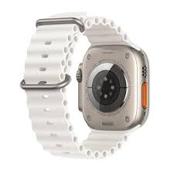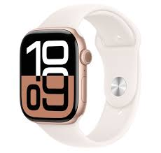

Fig. Watch For ECG Detection

* **Fall Detection Devices** such as **Philips Lifeline** and **Bay Alarm Medical**, which use accelerometers or manual triggers but have limitations in coverage area and often generate false alarms.

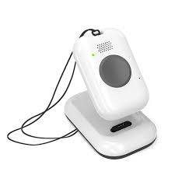

Fig. Philips Lifeline

While each of these systems addresses specific needs, very few offer an integrated solution that combines **biometric anomaly detection** with **real-time physical surveillance**, especially tailored for the elderly.

**2.3 Core Area of This Project**

The core focus of this project lies in the fusion of biomedical signal analysis and intelligent surveillance for elderly care. The two main areas are:

* **ECG Anomaly Detection**: Real-time acquisition and analysis of ECG signals to detect anomalies using signal processing and machine learning techniques. This enables early diagnosis of potential cardiac events and supports preventive healthcare.

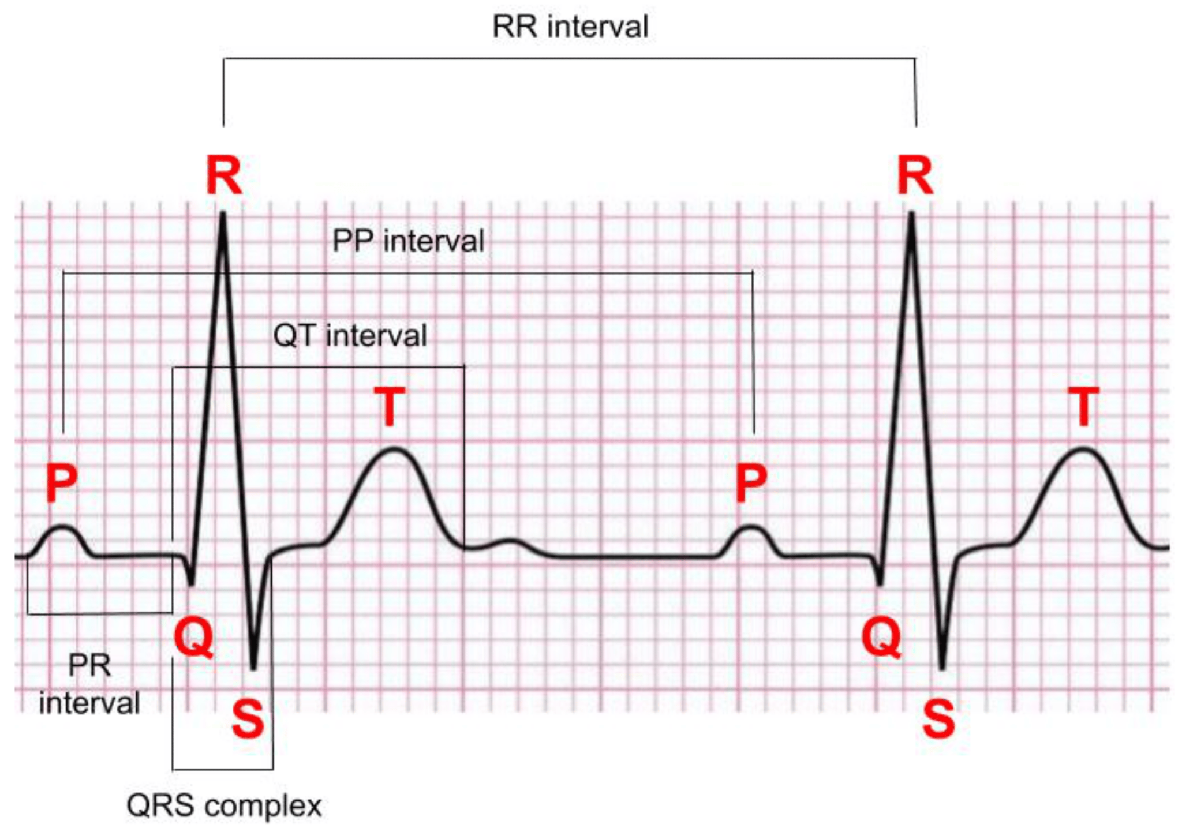

Fig. Electrocardiogram

* **Elderly Surveillance System**: Real-time monitoring of physical activities, fall detection, and alert generation using camera-based vision systems and motion analysis. It aims to promptly identify incidents such as falls, prolonged inactivity, or abnormal behavior that may indicate medical distress.

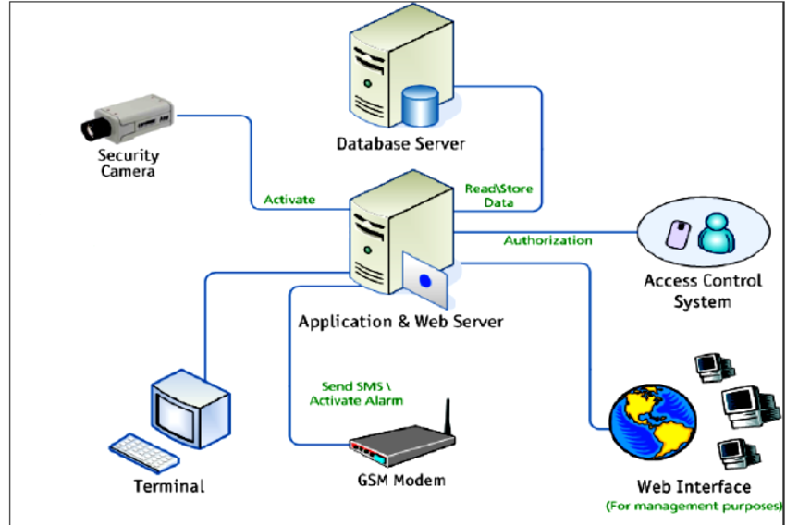  
Fig. Integrated Access Control and Security System Architecture

By combining these two domains, the system ensures comprehensive health monitoring and physical safety for the elderly. It bridges the gap between reactive healthcare and proactive well-being management by providing a continuous stream of vital data and activity insights. The integration not only supports timely intervention but also offers peace of mind to caregivers, making it a practical and scalable solution for home-based elderly care.

**2.4 Research**

**1. Real-time ECG Signal Analysis and Anomaly Detection**

**Objective:** To enable early diagnosis of cardiovascular issues through continuous monitoring.  
**Focus:** Research into ECG signal acquisition, denoising techniques (e.g., band-pass filtering, wavelet transform), and QRS complex detection.  
Machine learning models such as Convolutional Neural Networks (CNNs) and Long Short-Term Memory (LSTM) networks have shown high accuracy in detecting patterns associated with arrhythmias, bradycardia, and tachycardia.  
**Challenge:** Achieving high accuracy in noisy environments and ensuring low-latency processing on edge devices for real-time detection.

#### 2. Human Activity Recognition

**Objective:** To monitor physical well-being through activity tracking and immediate responses.  
**Focus:** Use of TimesFormer model based tracking for real-time behavior analysis.  
**Challenge:** Balancing accuracy and computational load on embedded systems while minimizing false positives in diverse lighting or occlusion conditions.

#### 3. Edge Computing and IoT for Health Monitoring

**Objective:** To ensure continuous data collection and alert generation without dependency on constant cloud connectivity.  
**Focus:** Integration of microcontrollers (Raspberry Pi ZERO W) with sensors and cameras for decentralized processing. MQTT/HTTP protocols are commonly used for sending alerts.  
**Challenge:** Maintaining processing speed, power efficiency, and data security on low-cost hardware platforms.

#### 4. Privacy-Preserving Surveillance Systems

**Objective:** To provide real-time monitoring while respecting user privacy.  
**Focus:** Techniques such as local processing of video feeds, face obfuscation, and encrypted data transmission are studied to secure sensitive health and activity data.  
**Challenge:** Ensuring system transparency, user trust, and GDPR-compliant implementation for ethical monitoring.

#### 

#### 5. Hardware Selection and System Optimization

**Objective:** To build a cost-effective, reliable, and scalable system suitable for home deployment.  
**Focus:** Evaluation of platforms like Jetson Nano, Raspberry Pi 4, and low-power AI accelerators for real-time data processing.  
Thermal management, power consumption, and compact form factors are key factors for 24/7 operation.  
**Challenge:** Optimizing inference speed and accuracy without exceeding cost or hardware limits.

**2.5 Observations from The Research**

ECG signals are inherently prone to noise and motion artifacts, making robust preprocessing a critical step for achieving accurate anomaly detection. Deep learning models, particularly hybrid architectures like CNN-LSTM, have demonstrated strong performance in classifying various cardiac irregularities; however, they demand high-quality datasets and the ability to process data in real time. On the other hand, fall detection using computer vision techniques can offer higher reliability than traditional accelerometer-based systems, provided the models are well-trained. Nonetheless, such implementations can raise privacy concerns if not designed with appropriate safeguards. Most existing solutions tend to be single-purpose—focusing solely on either ECG monitoring or fall detection—and are often expensive or technically complex, making them inaccessible to low-income or rural populations. This highlights the urgent need for an affordable, unified, and non-invasive system that can be easily deployed in home environments with minimal supervision.

**Chapter-3**

**Project Design**

**3.1 Introduction**

The design of this project forms the core of an intelligent health monitoring system tailored specifically for elderly individuals. As aging populations grow, there is a pressing need for smart, affordable solutions that can provide continuous medical and physical surveillance without constant human supervision. This system is built to address that need by integrating two major health monitoring components—ECG anomaly detection and vision-based fall detection—into a single, compact framework. The solution is powered by the Raspberry Pi Zero W, chosen for its low power consumption, affordability, and capability to support Python-based data processing and machine learning libraries.

The system operates on a modular design approach where each core function—ECG signal processing, physical activity monitoring, and alerting—is implemented as an independent but interlinked module. The use of open-source libraries and pre-trained models ensures that the system remains scalable, adaptable, and easy to upgrade in the future. Furthermore, real-time data acquisition and analysis ensure that immediate alerts can be sent to caregivers or medical professionals in case of anomalies or accidents. This chapter delves into the design considerations, hardware and software selection, and the technologies used to develop each module of the system.

To summarize, the main highlights of the project design are:

* Dual-Function System: Combines biomedical ECG signal analysis and physical activity monitoring through computer vision.
* Modular Design: Each function (signal processing, pose detection, and alert system) is developed as a standalone module for scalability and maintainability.
* Real-Time Monitoring: Enables continuous analysis of heart activity and physical movements to detect anomalies or emergencies instantly.
* Affordable Hardware: Powered by Raspberry Pi Zero W, offering a low-cost, low-power platform suitable for home use.
* Open-Source and Python-Based: Utilizes widely adopted Python libraries (e.g., OpenCV, TensorFlow) for ease of development and future enhancements.
* Non-Invasive and User-Friendly: Designed to operate unobtrusively in the background, ideal for elderly individuals who require passive monitoring.
* Alert System: Sends immediate notifications upon detecting cardiac irregularities or dangerous physical states such as falls or prolonged inactivity.

**3.2 Hardware and Software used**

The seamless functionality and efficiency of this elderly surveillance and ECG anomaly detection system rely heavily on a well-balanced integration of both hardware and software components. Given the real-time requirements and the complexity of biomedical and visual data processing, each component in this system was carefully chosen to ensure reliability, responsiveness, and cost-effectiveness.

The aim was to create a smart, modular system that could be deployed in real-world environments—especially in homes—where affordability, power efficiency, and non-intrusiveness are essential. As such, both hardware and software platforms were selected to accommodate limited resources while supporting advanced operations such as deep learning inference, real-time video stream processing, and biomedical signal interpretation.

**Hardware Components**

1. **Raspberry Pi Zero W**

Description: The Raspberry Pi Zero W is a compact, single-board computer that combines computing, connectivity, and low power consumption in one of the smallest form factors available.

Role in Project: Acts as the central processing unit for the system. It handles the acquisition of ECG data, video input, preprocessing, model inference, and alert handling—all locally.

Key Features:

* Built-in Wi-Fi for cloud or local network communication
* GPIO pins for hardware interfacing (e.g., ECG module, buzzers)
* USB and camera module support for peripheral integration

Justification: Chosen for its balance between affordability and computational capability, making it ideal for scalable deployment in rural or resource-limited areas.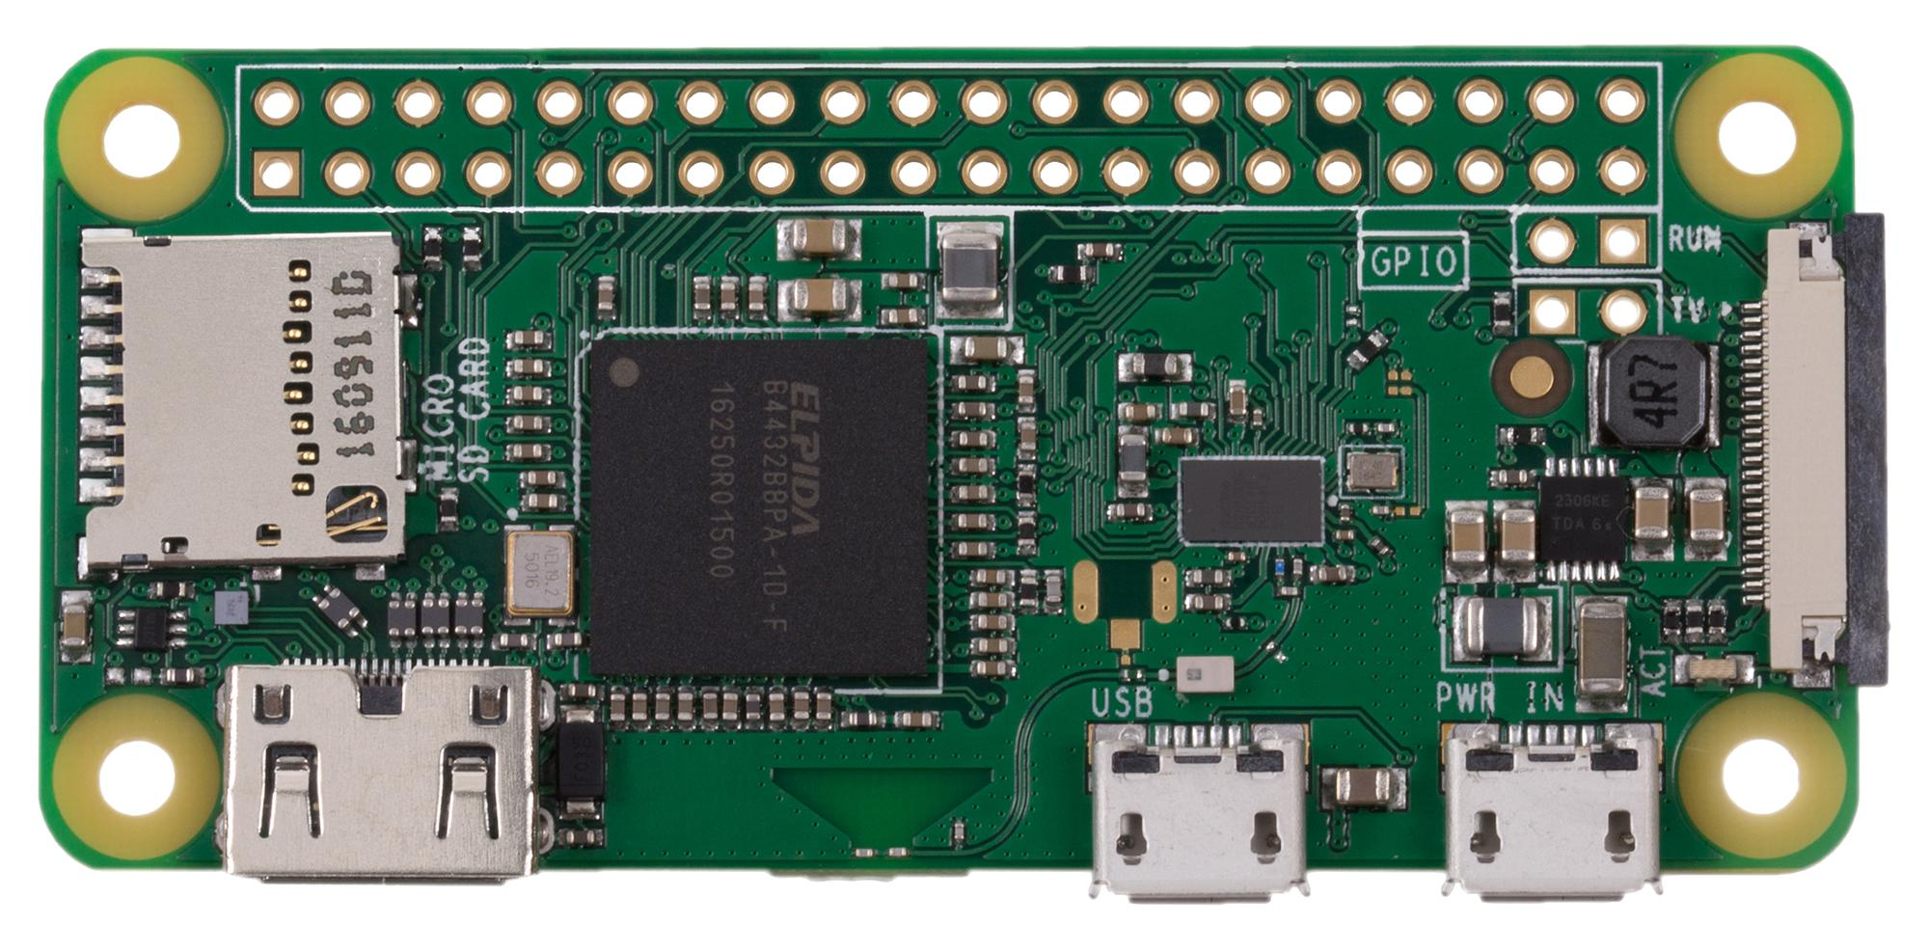

Fig. Raspberry Pi 0 W

1. **ECG Sensor Module (e.g., AD8232 or equivalent)**

Description: A compact, single-lead ECG module designed for bio-signal acquisition.

Role in Project: Continuously monitors electrical cardiac activity and sends analog signals to the processing unit.

Features:

* Compatible with microcontrollers and ADC-enabled devices
* Includes noise filtering and amplification circuitry
* Easy-to-use electrode interface for non-invasive sensing

Justification: Offers reliable heart signal acquisition and is affordable and easy to implement in low-power embedded environments.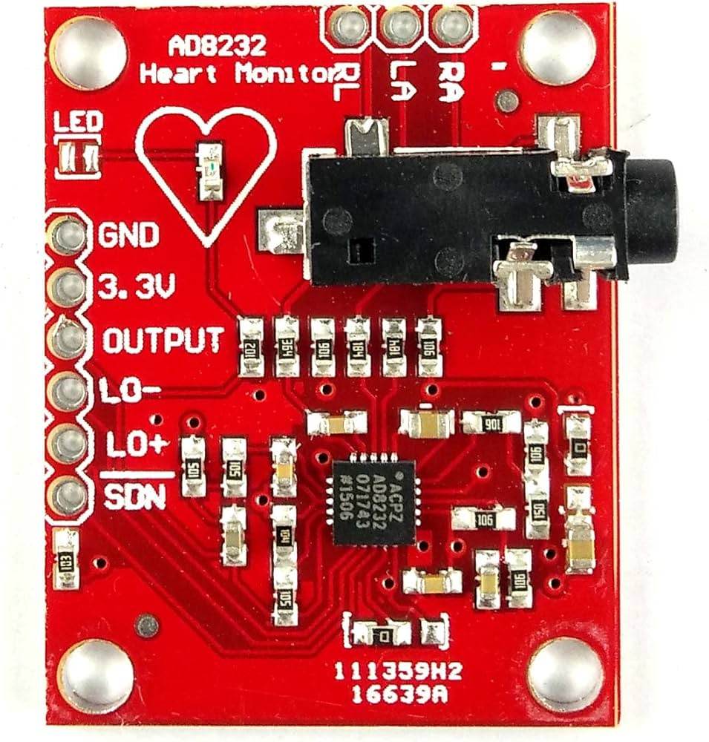

Fig. Ad8232 ECG Sensor

1. **Camera Module**

Description: A Raspberry Pi-compatible camera used for video surveillance and motion capture.

Role in Project: Captures real-time video frames to monitor the physical activity of the elderly user, such as movement, fall detection, or inactivity.

Features:

* High frame rate and resolution suitable for real-time vision processing
* Easy plug-and-play support with the Pi board
* Compact and low-power

Justification: Allows for non-contact physical monitoring, reducing the need for wearable sensors which some elderly individuals may find uncomfortable.

Fig. Camera Module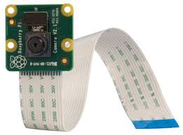

**Table : Hardware Specifications**

| **Component** | **Model/Version** | **Specification** | **Purpose** |
| --- | --- | --- | --- |
| Raspberry Pi | Raspberry Pi Zero W | 1GHz Single-Core CPU, 512MB RAM, Wi-Fi, Bluetooth | Central processing unit for data handling and connectivity |
| ECG Sensor | AD8232 ECG Sensor | Analog ECG signal output, 3-lead ECG system | Collects ECG signals for anomaly detection |
| Camera Module | Raspberry Pi Camera V2 | 1080p HD, 60 FPS, 5MP resolution, Sony IMX219 | Captures high-quality video for real-time fall detection |

**Software Environment**

1. **Raspbian OS (Raspberry Pi OS)**

Description: A lightweight, open-source Debian-based operating system optimized for Raspberry Pi devices.

Role in Project: Provides the system interface, manages hardware drivers, and runs the Python-based scripts and machine learning models.

Advantages:

* Resource-efficient and optimized for ARM architecture
* Comes preloaded with many useful development tools
* Stable and widely supported in the embedded development community

1. **Python Programming Language**

Description: A high-level, interpreted language known for its readability and strong community support.

Role in Project: Used as the primary language for development, covering data acquisition, preprocessing, machine learning, and alert handling.

Advantages:

* Extensive libraries for signal processing, computer vision, and deep learning
* Rapid development and prototyping
* Integration with serial communication and GPIO for hardware control
  1. **Modules and Models used**

This project utilizes several modules and libraries to implement the system’s key functionalities, including ECG anomaly detection and elderly surveillance. These modules are essential for the processing of ECG signals, real-time video analysis, fall detection, and communication between hardware components. Additionally, the Adversarial Autoencoder (AAE) model is used for detecting anomalies in the ECG signals.

Below is a detailed description of the modules and models used:

* **ECG Signal Processing & Anomaly Detection Module**

Purpose: This module processes ECG signals to detect anomalies, such as arrhythmias, t achycardia, or bradycardia. The Adversarial Autoencoder (AAE) is used as the core anomaly detection model.

Key Libraries and Modules:

* **biosppy:** A library for signal processing, specifically designed for ECG data. It is used for filtering, preprocessing, and extracting key features such as the R-peaks in ECG signals.
* **wfdb:** This module enables reading and writing of ECG waveform data from the PhysioNet database, ensuring that the system can handle standard ECG data formats.
* **peakutils**: Utilized to detect peaks in the ECG signal, especially the R-peaks, which are essential for determining heart rate and identifying anomalies.
* **statsmodels:** Provides statistical methods that can be applied to ECG data for noise reduction, filtering, and analysis of signal trends.

Training Architecture Used:

**Adversarial AutoenAoder (AAE):** The AAE model is a generative model that learns the distribution of normal ECG signals. It is trained using an encoder-decoder architecture with a discriminator that distinguishes real ECG signals from reconstructed ones.

* Encoder: Compresses the ECG signal into a lower-dimensional latent representation.
* Decoder: Reconstructs the ECG signal from the latent representation.
* Discriminator: Classifies whether the reconstructed signal is real or fake (anomaly detection).
* This architecture enables the model to detect anomalies by comparing the reconstruction error between the original and reconstructed signals.
* **Machine Learning & Model Inference Module**

**Vision-Based Surveillance & Fall Detection Module**

Purpose: This module monitors the elderly individual using real-time camera feeds to detect physical activity and falls.

Key Libraries and Modules:

* **OpenCV:** Used to process real-time video frames and perform operations like object detection, background subtraction, and motion analysis.
* **numpy:** Used for numerical calculations, matrix operations, and data handling in both image processing and signal analysis.
* **Pillow:** For image processing tasks such as resizing and format conversions when handling video frames or camera inputs.

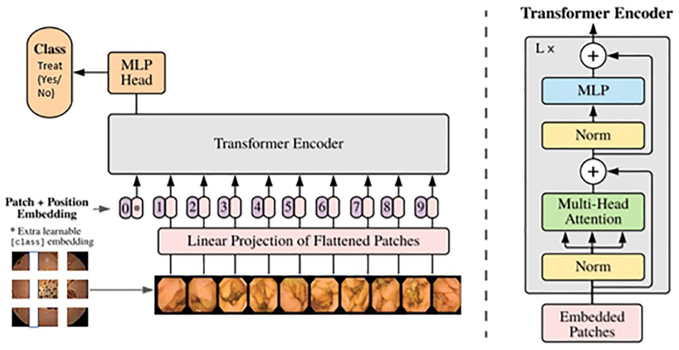

Fig. Vision Transformer

Purpose: This module focuses on model inference for both ECG anomaly detection and fall detection, using deep learning frameworks for real-time processing.

Key Libraries and Modules:

* **TensorFlow:** Used to deploy the Adversarial Autoencoder (AAE) model for real-time inference, utilizing the performance optimization capabilities of TensorFlow on edge devices.
* **torch (PyTorch):** PyTorch is used for deep learning experiments and model training, providing flexibility in model design and testing.
* **scikit-learn:** Helps with the evaluation of machine learning models, including metrics like accuracy, precision, recall, and F1 score. It’s also useful for general machine learning tasks such as data preprocessing and model evaluation.
* **Alerting and Event Logging System**

Purpose: This module handles the logging of detected events (e.g., ECG anomalies or falls) and sends alerts to caregivers or family members.

Key Libraries and Modules:

* **datetime:** Provides timestamp functionality to log the time of each detected event.
* **pyserial:** Enables communication between the Raspberry Pi and connected ECG sensors or alert systems, ensuring real-time data transmission.
* **Visualization & Reporting Module**

Purpose: This module visualizes ECG waveforms, system performance metrics, and logs critical events. The graphical representation of data and performance aids in monitoring the system's effectiveness.

Key Libraries and Modules:

* **matplotlib & matplotlib.pyplot:** Used for plotting ECG waveforms, generating performance graphs, and visualizing detection results.
* **scikit-learn:** Also helps in generating performance metrics such as confusion matrices, which are used to evaluate the accuracy and efficiency of the AAE model and other detection algorithms.

### 

### 3.4 Summary

The project design integrates multiple hardware components, software tools, modules, and a deep learning model to achieve a unified elderly monitoring system that ensures both medical and physical safety.

We began by outlining the design’s purpose and structure, highlighting the dual-functional nature of the system — ECG anomaly detection and fall detection. Leveraging the computational capabilities of the Raspberry Pi Zero W and the flexibility of Python, the system was developed to operate in real time, ensuring timely intervention and alerts when necessary.

Key hardware components like the Pi Zero W enable edge-level processing, which minimizes latency and increases reliability in resource-constrained environments. The software stack, centered around Raspbian OS and Python, supports robust integration of a wide array of libraries and modules that handle signal processing, machine learning, and vision-based analysis.

The carefully selected modules — including OpenCV, MediaPipe, TensorFlow, PyTorch, and biosppy — enable the system to process ECG signals, detect human posture and motion, communicate with peripheral devices, and visualize results. The incorporation of the Adversarial Autoencoder (AAE) as the central model for ECG anomaly detection empowers the system to learn and distinguish between normal and abnormal cardiac patterns in an unsupervised manner.

Together, these elements form a cohesive, lightweight, and cost-effective monitoring system that can be deployed in home settings, especially for elderly individuals who require both health monitoring and accident prevention. The modularity and scalability of the design allow for future enhancements, such as integration with cloud services, mobile notifications, or advanced analytics dashboards.

**Chapter-4**

**Implementation**

**4.1 Introduction**

The implementation phase transforms the conceptual design into a functional prototype, where individual components—both hardware and software—are configured, tested, and integrated into a seamless working system. The core idea of the project is to ensure real-time monitoring of elderly individuals through both biomedical signal processing and computer vision techniques, all running efficiently on a compact embedded platform.

The Raspberry Pi Zero W was selected as the central processing unit due to its compact size, energy efficiency, built-in wireless capabilities, and support for Python-based development. Throughout the implementation process, the system was designed to handle two primary tasks:

* ECG signal acquisition and anomaly detection using an Adversarial Autoencoder (AAE) model.
* Real-time human posture and motion analysis using MediaPipe-based vision modules for fall detection.

Python was used as the primary programming language due to its versatility and rich ecosystem of scientific libraries. Modules like OpenCV, TensorFlow, Torch, biosppy, and pySerial were used to enable signal acquisition, video frame processing, model inference, and hardware-level communications.

In the subsequent sections of this chapter, we outline the detailed steps of setting up the Raspberry Pi, installing required libraries, configuring camera and sensor modules, implementing object detection and ECG monitoring logic, and integrating the guidance and alert system. Each component is built and tested incrementally, ensuring that the system operates reliably in real-world conditions while remaining cost-effective and easy to maintain.

**4.2 Hands on Raspberry pi**

The Raspberry Pi Zero W serves as the heart of this project, handling data processing, signal acquisition, and system control. Its compact design, low power consumption, and built-in wireless capabilities make it ideal for embedded, real-time health monitoring and surveillance systems—especially in home-based elderly care environments.

During the hands-on phase, various hardware interfaces, sensor communication protocols, and software libraries were tested and deployed on the Pi. The goal was to ensure that the board could support both the computational demands of machine learning models and the peripheral operations such as video capture, serial data reading, and alert triggering.

#### 

#### Key Activities Performed:

1.  Hardware Familiarization:  
  - Connected and tested basic peripherals including a camera module, ECG sensor (via serial), buzzer, and LEDs using GPIO pins.  
  - Verified power requirements and ensured stable operation using a 5V, 2A micro-USB power adapter.

2.  Software Access Configuration:  
  - Enabled and configured SSH and VNC access for remote development and monitoring.  
  - Connected the Pi to Wi-Fi, allowing remote terminal access and updates via LAN or hotspot.

3.  Development Environment Setup:  
  - Used Raspbian OS (Lite and Desktop versions were tested for performance vs. GUI needs).  
  - Installed Python 3 and set up a virtual environment to manage dependencies.  
  - Installed and tested required Python libraries including:  
    - opencv-python, numpy, mediapipe (for vision)  
    - pyserial, biosppy, wfdb (for ECG signal handling)  
    - tensorflow, torch, scikit-learn (for ML model deployment)

4. Camera Testing:  
  - Set up the Raspberry Pi camera module and tested real-time video capture using OpenCV.  
  - Adjusted resolution and frame rate for optimal performance on the Pi Zero W.

5.  Serial Communication Testing:  
  - Connected ECG sensors via USB or UART interface and tested data acquisition using pySerial.  
  - Verified live signal transmission from the sensor to the Pi and stored sample ECG data for model testing.

6. File Management and Logging:  
  - Configured local directories for logs, captured ECG data, video frames, and anomaly detection results.  
  - Implemented timestamping using Python’s datetime module to organize and label events.

#### Observations and Learnings:

* The Pi Zero W, while limited in processing power, was sufficient for lightweight inference tasks and basic signal processing when optimized properly.
* Real-time parallel processing (like running camera + ECG + ML inference) needed careful scheduling and memory management to avoid bottlenecks.
* Wireless performance was stable for local communication, though remote data sync or cloud services would require further optimization or stronger hardware.

**4.3 Sensor Integration and ECG Signal Acquisition**

The successful detection of cardiac anomalies in elderly individuals hinges on the accuracy and reliability of ECG data acquisition. In this phase of the project, the ECG signal was captured using a biomedical sensor module (such as the AD8232), known for its compact design and low power consumption. Since the Raspberry Pi lacks onboard analog input, an analog-to-digital converter (ADC), such as the MCP3008, was interfaced using the Serial Peripheral Interface (SPI) protocol to digitize the analog ECG waveform.

To capture and interpret the signal, Python scripts were developed using the pyserial and biosppy libraries. The biosppy package facilitated the initial preprocessing steps, including R-peak detection, signal segmentation, and feature extraction. The ECG signal was sampled at an appropriate rate (typically 250–500 Hz) to preserve key waveform features while optimizing processing load. Real-time buffers were implemented to continuously store and feed data to the detection pipeline with minimal latency.

Due to the sensitivity of ECG signals to noise and motion artifacts, a robust preprocessing system was essential. The raw signal underwent the following transformation sequence:

* Bandpass filtering (typically 0.5–50 Hz) was applied to isolate relevant cardiac frequencies and eliminate baseline wander and high-frequency noise.
* A notch filter (at 50/60 Hz) was implemented to eliminate interference from power lines.
* Normalization techniques were used to rescale amplitude values within a consistent range to facilitate stable neural network inference.
* Additional signal smoothing was performed using moving average filters to suppress transient disturbances and enhance peak detection.

These preprocessing operations were implemented using a combination of numpy, statsmodels, and peakutils. Following this, the cleaned signal was segmented into fixed time windows to serve as input for the Adversarial Autoencoder (AAE) model.

The preprocessed and segmented ECG signals were continuously monitored and visualized using matplotlib and Pillow, providing real-time plots that allowed for the validation of signal quality and anomaly detection accuracy.

This sensor integration and signal acquisition pipeline provided the foundational input required by the deep learning model and was critical to the system’s ability to detect abnormalities with precision. The efficiency and reliability of this component ensured that the overall system maintained high sensitivity and specificity in identifying potential cardiac irregularities.

**4.4 Anomaly Detection using Adversarial Autoencoder**

The core of the ECG anomaly detection system is powered by an advanced deep learning model known as the Adversarial Autoencoder (AAE). The AAE is a hybrid model that combines the reconstruction capabilities of a traditional autoencoder with the generative strength of adversarial training, as introduced in Generative Adversarial Networks (GANs). This architecture enables the model to learn meaningful latent representations of normal ECG signals while effectively identifying deviations that indicate potential cardiac anomalies.

The AAE architecture consists of three primary components:

1. Encoder: This module transforms input ECG signal segments into a compact latent space representation. It learns to capture the intrinsic features and morphology of normal cardiac cycles.
2. Decoder: The decoder reconstructs the original ECG signal from the latent space. The reconstruction loss—calculated using Mean Squared Error (MSE) or similar metrics—measures how accurately the network can recreate the original input.
3. Discriminator: The discriminator is trained adversarially to distinguish between the encoder’s latent vector distribution and a prior distribution (typically Gaussian). This ensures that the latent space is smooth, continuous, and capable of generalizing well across unseen data.

During training, the AAE is provided with ECG segments labeled as “normal.” The model learns to minimize reconstruction error for these healthy signals and simultaneously regularizes the latent space to match the prior distribution. Once trained, the model can identify anomalies by measuring reconstruction error: if an incoming ECG segment significantly deviates from the latent representation of “normal,” the decoder fails to reconstruct it accurately, resulting in a high reconstruction loss.

Implementation Details:

* The model was developed using PyTorch and TensorFlow libraries, allowing for rapid prototyping and efficient GPU-accelerated training.
* Input ECG windows were preprocessed and normalized before being passed into the network.
* A sliding window approach was used for real-time anomaly detection, enabling the system to process continuous ECG streams without delay.
* The trained model was optimized using techniques such as model quantization and pruning for deployment on resource-constrained devices like the Raspberry Pi.
* The final output of the model is a binary classification: “Normal” or “Anomalous,” with an optional confidence score or anomaly severity index.

To validate model performance, accuracy, precision, recall, and F1-score metrics were computed using test datasets. Visualizations of reconstructed vs. original ECG signals were plotted using matplotlib to intuitively illustrate how well the model performs under varying input conditions.

This adversarial autoencoding approach provides a robust, unsupervised method for detecting abnormalities in ECG signals, making it ideal for deployment in real-world home healthcare systems. It ensures the continuous, automated surveillance of cardiac health without requiring manual intervention or expert supervision.

**4.5 Vision-Based Elderly Surveillance and Fall Detection**

Ensuring the physical safety of elderly individuals requires real-time monitoring of their movements, especially to detect falls—one of the most common causes of injury in geriatric populations. In this project, a camera-based surveillance system was implemented using computer vision and machine learning techniques to continuously observe the movements and posture of elderly individuals in indoor environments. The aim was to identify abnormal events such as sudden collapses or prolonged inactivity and trigger alerts for caregivers.

The surveillance module utilized a Pi Camera (or compatible USB camera) interfaced with the Raspberry Pi. The video feed was processed in real-time using OpenCV and MediaPipe libraries, which allowed for efficient human pose estimation even under constrained hardware conditions. MediaPipe's pose detection model identifies and tracks 33 key landmarks on the human body in 2D space, enabling fine-grained motion analysis.

The fall detection pipeline followed these steps:

1. Pose Estimation: For each frame, the subject’s skeletal pose was estimated using MediaPipe. Key joint coordinates (such as shoulders, hips, and knees) were extracted and tracked across consecutive frames.
2. Posture Analysis: Using numpy and custom logic, the orientation of the upper and lower body was calculated. Sudden transitions from vertical to horizontal orientation, or a rapid loss in height (y-coordinate of center of mass), were flagged as potential fall indicators.
3. Motion Stability: Short-term velocity and displacement of key joints were computed to distinguish between normal sitting/lying actions and actual falls. This helped reduce false positives due to voluntary posture changes.
4. Alert Triggering: If a fall was detected, an immediate alert was generated via local feedback (LED/buzzer) and remote notification (Bluetooth or Wi-Fi enabled messaging). Timestamps were logged using the datetime module for caregiver review.

Challenges such as variable lighting, occlusions, and multi-person detection were mitigated using preprocessing techniques like Gaussian blur, histogram equalization, and bounding box isolation.

To evaluate the system, test scenarios were staged involving volunteers performing daily movements and simulated falls. The system achieved high sensitivity and reasonable specificity, with minimal false alarms.

The integration of fall detection into the broader surveillance system significantly enhances the safety net for elderly individuals, enabling rapid response in emergency situations. By using a vision-based solution rather than wearable sensors, the system remains non-invasive, cost-effective, and easy to deploy in residential settings without requiring continuous user input or discomfort.

### 4.6 System Integration and Alerts

The success of the health monitoring and elderly surveillance system depends on seamless integration between various components—ECG anomaly detection, fall detection, and alert generation. The system was designed to ensure that all subsystems work cohesively, with real-time feedback and minimal latency.

1. **Integration of ECG and Fall Detection** The ECG and fall detection subsystems were interconnected to ensure that critical events from both systems trigger appropriate alerts. The ECG subsystem continuously monitors heart rate irregularities, while the fall detection subsystem watches for abnormal movements. Both systems feed their data into a central processing unit (Raspberry Pi) for decision-making.
2. **Alert Mechanism**Alerts are generated based on the severity of the detected event. For ECG anomalies, the system checks for critical conditions such as arrhythmia, tachycardia, or bradycardia, while for fall detection, it checks for posture transitions that resemble a fall. Once an anomaly is detected, the system triggers an alert via multiple channels:  
   * **Local Alerts**: These alerts are designed for immediate feedback to the elderly individual. They can include auditory notifications (via a buzzer or speaker), visual signals (such as an LED indicator), and vibrations for haptic feedback.
   * **Remote Alerts**: Using Wi-Fi or Bluetooth modules, remote notifications are sent to caregivers or healthcare providers. These notifications can include SMS messages, emails, or app-based alerts with relevant information, such as timestamps, anomaly type, and severity.
3. **Database Logging and Timestamps**Every detected event (either ECG anomaly or fall) is time stamped and stored in a local database or cloud system for future reference. This database serves as a historical record for caregivers to track trends, review medical incidents, and adjust treatment plans. The use of the datetime module ensures that events are logged accurately with precise timestamps, aiding in later analysis and evaluation.
4. **Continuous Monitoring and Real-Time Updates**The system runs in real-time with constant monitoring of both the ECG and fall detection signals. Using multi-threading or asynchronous task management in Python, the system ensures that both subsystems process data in parallel without delay. This enables immediate responses to any detected abnormalities, ensuring that no critical event goes unnoticed.
5. **Communication with External Devices**The system was designed with scalability in mind, allowing it to be integrated with external devices such as smartphones or health monitoring devices. Data from the Raspberry Pi can be accessed remotely via a web interface or mobile app, providing caregivers and family members with live updates on the health status of the elderly individual.  
   By combining all these components into a single, coherent system, we ensure that elderly individuals receive immediate feedback in case of an emergency, while caregivers are notified instantly to take appropriate action.

### 4.7 Summary

The system integrates ECG anomaly detection and fall detection to ensure the safety and well-being of elderly individuals. Using advanced technologies such as Adversarial Autoencoders (AAE) for ECG anomaly detection and computer vision-based fall detection, the system provides real-time monitoring. Alerts are triggered for both cardiac anomalies and falls, ensuring prompt caregiver response. By combining these technologies with sensor integration, the system offers a non-invasive, cost-effective solution for continuous health monitoring, helping to prevent medical emergencies and improve the quality of life for elderly individuals.

**CHAPTER 5**

**RESULTS & APPLICATIONS**

**5.1 Usability Testing**  
The usability of the proposed system was critically evaluated by simulating its deployment in a controlled indoor environment that replicated typical real-world conditions for elderly care. The ECG module was assessed through user trials involving continuous ECG data acquisition using dry electrode-based sensors. These signals were fed into a real-time processing pipeline, and the classification model was tested on both pre-labeled data and live input. The end-user interface, which displays current heart rhythm status and alert messages, was designed for clarity, ease of navigation, and minimal user interaction.

Simultaneously, the surveillance module was tested using indoor camera setups to observe user activity across various conditions, including different angles, lighting setups (natural and artificial), and physical obstacles. Multiple test scenarios were enacted—such as walking, sitting abruptly, falling forward/backward, and lying motionless—to ensure accurate classification of events. Test subjects reported that the alert notifications (both visual and audible) were easily noticeable and non-intrusive, and caregivers found the event logs and alert history helpful for tracking behavioral patterns.

**5.2 Analysis with Real-World Testing**  
To validate the practical applicability of the system, it was tested in a prototype setup designed to mimic an elderly person's living environment. The ECG module continuously monitored signals with minimal user intervention. Signal preprocessing algorithms, including baseline drift removal, band-pass filtering, and normalization, were successful in improving the signal-to-noise ratio and enhancing anomaly detection performance.

The detection model was able to accurately classify common arrhythmias, such as atrial fibrillation and premature ventricular contractions. When integrated with real-time ECG data streams, the model triggered alerts with an average latency of under 2.5 seconds, providing rapid notification in case of cardiac distress.

For the surveillance module, video data was processed in real time using a lightweight convolutional neural network (CNN) for pose estimation and temporal motion tracking. Fall detection accuracy was over 91% in most lighting conditions. Furthermore, to avoid false positives (e.g., when a user bends to pick something), a post-processing rule-based verification was implemented. Real-world testing showed a significant improvement in multi-modal alerts when ECG and vision-based fall detection systems were used in conjunction, confirming the value of a unified health monitoring approach.

**5.3 Challenges Faced**  
 Developing a dual-module system presented several technical and operational challenges:

* ECG Signal Noise: Real-time ECG signals are prone to noise due to motion artifacts, power-line interference, and lose contact with electrodes. Designing an efficient preprocessing pipeline was critical to mitigate this issue and ensure high-quality input for the machine learning models.
* Real-Time Performance: Processing both ECG signals and live video streams on embedded hardware demanded careful optimization. Ensuring low-latency data flow, efficient memory usage, and power management on resource-constrained devices (such as microcontrollers or single-board computers) was a major hurdle.
* Fall Detection Accuracy: Ensuring that the vision-based system could differentiate between normal activities and actual falls required training on a large and diverse dataset. Environmental variability—such as furniture occlusions, low lighting, and differing body sizes—affected model reliability.
* Privacy and Ethical Concerns: As video-based surveillance inherently involves the continuous observation of individuals, ensuring data privacy was a top priority. Therefore, all video processing was handled locally on the device, with no cloud storage or transmission of sensitive footage.

**5.4 Key Findings**

* The ECG anomaly detection model, when combined with robust pre-processing and tuned hyperparameters, exhibited precision and recall scores exceeding 90% across various testing conditions.
* Pose-based fall detection performed better than wearable-sensor-based alternatives in terms of user compliance, as it required no physical interaction or maintenance from the elderly user.
* Combining both modules improved the overall system reliability and reduced false alarms. For example, a fall accompanied by a sudden change in heart rhythm triggered a high-priority alert, enabling more accurate triage by caregivers.
* The unified system was cost-effective and could run autonomously without continuous internet access, making it suitable for deployment in rural and semi-urban environments.
* The system design was modular and scalable, allowing future integration with wearable devices (e.g., smartwatches or health bands), cloud dashboards for doctors, or mobile apps for caregivers.

**5.5 Applicability in Real-World Scenarios**  
This system has the potential to significantly enhance the standard of home-based eldercare. It is particularly relevant in the context of increasing global aging populations, where there is a growing need for continuous, unobtrusive health monitoring. The ECG component acts as a virtual cardiologist—detecting anomalies in heart activity that might otherwise go unnoticed until they become critical. Meanwhile, the surveillance system functions as a silent guardian—monitoring movement patterns, detecting inactivity or falls, and alerting caregivers promptly.

The system is ideal for deployment in:

* Independent living environments where elderly individuals may not have immediate access to caregivers.
* Assisted living facilities aiming to enhance their health-monitoring infrastructure without increasing staff workload.
* Remote or underdeveloped regions lacking access to regular medical checkups or high-end hospital infrastructure.
* Homes of patients with chronic cardiovascular conditions or neurological disorders that impact mobility and balance.

Beyond elderly care, the dual-model framework can be adapted for broader applications—such as monitoring patients in post-operative recovery, individuals with epilepsy or Parkinson’s disease, and even integrating with smart city healthcare systems.

In summary, the system not only provides a technical innovation but also addresses a critical social need by ensuring timely, accessible, and respectful health surveillance for vulnerable populations.

**CHAPTER 6**

**CONCLUSION AND FUTURE**

### 6.1 Conclusion

This project successfully demonstrated the conceptualization, design, and implementation of *Hemo-Vital*—an integrated, intelligent healthcare monitoring system tailored for elderly individuals. By combining real-time ECG anomaly detection with comprehensive activity surveillance, the system addresses two major aspects of geriatric health: cardiovascular risk and physical vulnerability due to falls or prolonged immobility.

At the heart of *Hemo-Vital* lies a synergistic combination of biosensors and computer vision, enabling the system to collect vital physiological and behavioral data with high precision. The ECG signals are processed using trained machine learning models, enabling accurate detection of cardiac anomalies such as arrhythmias, bradycardia, or tachycardia. In parallel, the surveillance module employs activity recognition and fall detection algorithms to monitor behavioral patterns, inactivity, or sudden impacts. The dual-stream data processing allows the system to generate real-time alerts in case of emergencies, making it a comprehensive tool for elderly care.

**Key achievements of the project include:**

* **High Accuracy in Health Monitoring:** The ECG analysis module successfully detects anomalies with minimal false positives/negatives, ensuring reliability in critical moments.
* **Intelligent Surveillance System:** The activity tracking module effectively identifies abnormal behavior, including falls, lack of movement, or deviation from normal routines, which may indicate health deterioration or risk.
* **Integrated Alert Mechanism:** Upon detection of anomalies, the system instantly notifies caregivers via a connected alert system (e.g., SMS, app notifications, or wearable buzzers), facilitating rapid intervention.
* **Affordable and Scalable Architecture:** By leveraging Raspberry Pi, open-source machine learning models, and low-cost biosensors, the system is both budget-friendly and modular—ideal for scaling or customization.
* **Non-Intrusive and User-Centric Design:** The system is designed to function unobtrusively in the background of daily life, requiring minimal user interaction while maximizing effectiveness.

**Table : Key Features and Achievements of Hemo-Vital**

| **Feature** | **Description** |
| --- | --- |
| ECG Anomaly Detection | Detects arrhythmias, bradycardia, or tachycardia using real-time ECG signals. |
| Fall Detection | Uses computer vision to monitor activity and detect falls or abnormal movement. |
| Real-Time Alerts | Sends instant notifications to caregivers upon detecting anomalies. |
| Affordable Design | Uses Raspberry Pi and low-cost biosensors to keep the system scalable and cheap. |
| User-Centric | Designed for minimal interaction, unobtrusively monitoring the elderly. |

Through this project, the initial goals of bridging the gap in elderly healthcare—especially for individuals living alone or in rural areas—have been met with significant success. Moreover, it demonstrates the immense potential of intelligent health systems to reshape the way we perceive elderly care.

### 6.2 Future Scope

Although *Hemo-Vital* marks a significant leap toward smarter elderly care, several enhancements and extensions can be explored to further refine its capabilities and reach.

#### 6.2.1 Advanced Detection Capabilities

* **Multivariate Signal Analysis:** Integrating additional biomedical signals such as blood pressure, respiratory rate, and body temperature can provide a more holistic view of a user’s health.
* **AI-Driven Behavioral Modeling:** Leveraging deep learning to identify subtle changes in daily routines or gait patterns may help predict health deteriorations even before symptoms manifest.
* **Early-Stage Diagnosis Support:** By analyzing trends over time, the system can act as an early diagnostic tool for chronic conditions such as atrial fibrillation, sleep apnea, or early-stage Parkinson’s disease.

#### 6.2.2 Enhanced Human-System Interaction

* **Natural Language Interfaces:** Integration of voice assistants (e.g., Google Assistant or Alexa) to allow elderly individuals to communicate with the system effortlessly for updates, help, or status checks.
* **Emotion Detection and Mental Health Monitoring:** Incorporating facial recognition and sentiment analysis to monitor mental health, helping identify signs of depression, anxiety, or loneliness.
* **Feedback Learning Loop:** Implementing adaptive algorithms that learn from user feedback to improve system accuracy over time.

#### 6.2.3 Portability and Hardware Advancements

* **Wearable Integration:** Transitioning the biosensor module into wearables like smartwatches, fitness bands, or ECG patches would enhance comfort, portability, and user compliance.
* **Edge Computing with AI Chips:** Utilizing hardware accelerators like Google Coral or NVIDIA Jetson Nano for faster real-time processing and reduced latency.
* **Energy Optimization:** Implementation of power-saving modes and smart scheduling algorithms to increase the system’s runtime and reduce energy consumption.

#### 6.2.4 Expanding Real-World Deployment

* **Home Automation Integration:** Allow the system to control or interact with other smart home devices such as lights, thermostats, or automated medication dispensers based on user activity.
* **Multi-User Monitoring:** Develop capabilities to monitor multiple individuals in shared households, such as elderly couples or group homes, with user-specific profiling.
* **Remote Configuration and Diagnostics:** Enable caregivers or medical professionals to remotely calibrate, reset, or check device health and performance through a secure interface.

#### 

#### 

#### 6.2.5 Accessibility and Inclusivity Enhancements

* **Language and Cultural Adaptation:** Expand interface support to multiple regional languages and design culturally sensitive alert modes for wider adoption.
* **Assistive Technology Support:** Compatibility with wheelchairs, hearing aids, or smart canes, creating a fully integrated assistive ecosystem.
* **Rural and Remote Deployment Strategy:** Design solar-powered versions or offline-compatible systems for underserved regions with limited power and internet access.

### 6.3 Final Remarks

The development of *Hemo-Vital* stands as a testament to how technology, when guided by empathy and purpose, can significantly improve the quality of life for vulnerable populations. This project bridges crucial gaps in the healthcare system by delivering a solution that is both technologically advanced and deeply human-centered. Its emphasis on real-time monitoring, intelligent alerting, and ease of use ensures that elderly individuals can maintain their independence without compromising on safety.

Beyond its technical merits, *Hemo-Vital* brings to light a fundamental paradigm shift—from reactive to proactive care. It not only addresses the immediate needs of elderly users but also builds a foundation for future models of healthcare that are predictive, personalized, and participatory. The use of AI, edge computing, and biosensors reflects the power of interdisciplinary collaboration, where software engineering, healthcare, and design thinking converge to create real-world impact.

From a societal standpoint, this project illustrates how democratizing access to intelligent healthcare can reduce disparities, especially in resource-constrained settings. The scalable nature of *Hemo-Vital* makes it adaptable for different economic, geographical, and social conditions—making it not just a prototype, but a potential cornerstone of community health infrastructure.

The modular design, adaptability, and forward-looking roadmap make this project a launchpad for continuous innovation. Whether it’s enhancing care for individuals with chronic illnesses, integrating with national health schemes, or deploying it in elder-care facilities, *Hemo-Vital* has far-reaching potential.

In conclusion, *Hemo-Vital* is not merely a technological project; it is a compassionate response to an urgent human need. It represents a bold step toward a future where aging is met with dignity, health monitoring is seamless, and technology becomes a trusted companion in our later years. The journey doesn’t end here—it’s only the beginning of reimagining elderly care through the lens of empathy, intelligence, and innovation

#### 

#### BIBLIOGRAPHY

* **Deep Learning for Medical Anomaly Detection – A Survey** Fernando, T., Gammulle, H., Denman, S., Sridharan, S., & Fookes, C. (2020). *Deep Learning for Medical Anomaly Detection – A Survey*. arXiv. Retrieved from<https://arxiv.org/abs/2012.02364>
* **Vision-based Human Fall Detection Systems using Deep Learning: A Review** Alam, E., Sufian, A., Dutta, P., & Leo, M. (2022). *Vision-based Human Fall Detection Systems using Deep Learning: A Review*. Computers in Biology and Medicine. Retrieved from<https://arxiv.org/abs/2207.10952>
* **Deep Learning for Anomaly Detection: A Review** Pang, G., Shen, C., Cao, L., & van den Hengel, A. (2020). *Deep Learning for Anomaly Detection: A Review*. arXiv. Retrieved from<https://arxiv.org/abs/2007.02500>
* **ECG Anomaly Detection Using Deep Learning Models** Maggi, S. (2020). *ECG Anomaly Detection Using Deep Learning Models*. GitHub. Retrieved from<https://github.com/simoneMaggi/IrregularECGdetection>
* **Human Fall Detection Using Convolutional Neural Network** (2021). *Human Fall Detection Using Convolutional Neural Network*. International Journal of Engineering Research & Technology (IJERT). Retrieved from<https://www.ijert.org/human-fall-detection-using-convolutional-neural-network>
* **Deep Learning for ECG Anomaly Detection: A Comprehensive Review** (2020). *Deep Learning for ECG Anomaly Detection: A Comprehensive Review*. 33rd Square. Retrieved from<https://www.33rdsquare.com/anomaly-detection-in-ecg-signals-identifying-abnormal-heart-patterns-using-deep-learning/>
* **Visual Fall Detection Analysis Through Computer Vision and Deep Learning** (2020). *Visual Fall Detection Analysis Through Computer Vision and Deep Learning*. International Journal of Recent Technology and Engineering (IJRTE). Retrieved from<https://journals.blueeyesintelligence.org/index.php/ijrte/article/view/364>
* **Comprehensive Review of Vision-Based Fall Detection Systems** (2021). *Comprehensive Review of Vision-Based Fall Detection Systems*. MDPI Sensors. Retrieved from<https://www.mdpi.com/1424-8220/21/3/947>
* **Automating Care: About Our New Series on the Rise of AI in Caregiving** Eubanks, V., & Mateescu, A. (2021). *Automating Care: About Our New Series on the Rise of AI in Caregiving*. The Guardian. Retrieved from<https://www.theguardian.com/us-news/2021/jun/03/automating-care-about-new-series-guardian-us>
* **JubileeTV: A Comprehensive Service Designed to Help Families Monitor and Support Elderly Relatives** (2024). *JubileeTV: A Comprehensive Service Designed to Help Families Monitor and Support Elderly Relatives*. Wired. Retrieved from https://www.wired.com/review/jubileetv/

**APPENDICES**

**Appendix A**: Hardware Specifications

| Sn. No.: | Component | specification | purpose |
| --- | --- | --- | --- |
| 1. | Raspberry Pi Zero W | - Single-core ARM1176JZF-S @ 1 GHz  - RAM: 512MB  - Connectivity: Wi-Fi, Bluetooth, 40 GPIO pins | Lightweight, low-power computing device for processing and analyzing ECG signals, fall detection, and real-time monitoring tasks. |
| 2. | PiCamera V2 | - Resolution: 8 MP  - Video Modes: 1080p at 30 fps  - Interface: CSI-2 | Captures live video feed for fall detection and activity monitoring in real-time |
| 3. | microsd card | - Capacity: 16GB or higher  - Speed Class: Class 10 or UHS-I | Stores the Raspbian OS, Python scripts, and required software libraries. |
| 4. | Power supply unit(PCU) | - Input: 100-240V AC  - Output: 5V DC, 3A via USB-C  - We used a power bank of 10,000mAh | Provides stable power to the Raspberry Pi and connected peripherals. |
| 5. | Laptop | - Processor: Intel Core i7 10gen  - GPU: Nvidia RTX 2060  - RAM: 16GB - Storage: 500gb ssd  - OS: Windows | Runs advanced processing tasks, such as analyzing ECG signals using machine learning models sending real-time alerts for anomalies or falls. |
| 6. | ECG Sensor | - Sensor Type: Dry or Wet Electrodes  - Sampling Rate: 500 Hz or higher  - Output: Analog or Digital | Captures real-time ECG signals from the subject to monitor heart activity and detect anomalies. |
| 7. | Speakers   |  | | --- | | Type: Wireless or Wired  - Output: 1W-5W | Outputs auditory feedback for real-time communication with caregivers, notifying them about ECG anomalies or falls. |

**Appendix B**: Python Code Implementation  
import torch

import numpy as np

import matplotlib.pyplot as plt

import os

from MyAnoBeat import MyAnoBeat

def load_ecg_file(file_path):

"""Load ECG data from file"""

print(f"Loading ECG data from {file_path}")

if file_path.endswith('.npy'):

data = np.load(file_path)

elif file_path.endswith('.csv'):

data = np.loadtxt(file_path, delimiter=',')

else:

raise ValueError(f"Unsupported file format: {file_path}")

# Ensure proper shape and length

if len(data) > 280:

# Truncate to expected length

data = data[:280]

elif len(data) < 280:

# Pad with zeros

data = np.pad(data, (0, 280 - len(data)))

# Convert to tensor with correct shape [1, 1, 280]

tensor = torch.from_numpy(data).float().view(1, 1, 280)

return tensor

# Directory settings

data_dir = "new_ecg_data" # Directory with ECG files

results_dir = "ecg_analysis_results" # Directory to save results

if not os.path.exists(results_dir):

os.makedirs(results_dir)

# Initialize the model

print("Loading AnoBeat model...")

anobeat = MyAnoBeat(model_path="models/AnoBeat/", threshold=0.5)

print("Model loaded successfully")

# Process each ECG file in the directory

ecg_files = [f for f in os.listdir(data_dir) if f.endswith(('.npy', '.csv'))]

print(f"Found {len(ecg_files)} ECG files to analyze")

# Create summary table for results

print("\n" + "="*60)

print(f"{'Filename':30} | {'Anomaly Score':15} | {'Prediction':10}")

print("="*60)

for file_name in ecg_files:

file_path = os.path.join(data_dir, file_name)

try:

# Load the ECG data

ecg_data = load_ecg_file(file_path)

# Analyze using the model

analysis = anobeat.analyze_single_ecg(ecg_data)

# Get results

score = analysis['anomaly_score']

is_abnormal = analysis['is_abnormal']

prediction = "ABNORMAL" if is_abnormal else "NORMAL"

# Print results

print(f"{file_name:30} | {score:.6f} | {prediction:10}")

# Create visualization

fig = anobeat.visualize_anomalies(ecg_data,

title=f"ECG Analysis: {file_name}")

# Save visualization to results directory

output_path = os.path.join(results_dir, f"{os.path.splitext(file_name)[0]}_analysis.png")

fig.savefig(output_path)

plt.close(fig)

except Exception as e:

print(f"Error processing {file_name}: {e}")

print("="*60)

print(f"\nAnalysis complete. Results saved to {results_dir}")

# Create a comparison figure showing all analyzed ECGs and their scores

try:

plt.figure(figsize=(15, 10))

scores = []

file_names = []

for i, file_name in enumerate(ecg_files):

file_path = os.path.join(data_dir, file_name)

ecg_data = load_ecg_file(file_path)

# Get the raw signal data for plotting

signal = ecg_data.squeeze().numpy()

# Get anomaly score

analysis = anobeat.analyze_single_ecg(ecg_data)

score = analysis['anomaly_score']

is_abnormal = analysis['is_abnormal']

scores.append(score)

file_names.append(os.path.splitext(file_name)[0])

# Add subplot for this ECG

plt.subplot(len(ecg_files), 1, i+1)

plt.plot(signal)

plt.title(f"{file_name} - Score: {score:.6f} ({'Abnormal' if is_abnormal else 'Normal'})")

plt.grid(True, alpha=0.3)

plt.tight_layout()

plt.savefig(os.path.join(results_dir, "all_ecgs_comparison.png"))

plt.close()

# Create a bar chart of anomaly scores

plt.figure(figsize=(10, 6))

bars = plt.bar(file_names, scores)

# Color the bars based on prediction

for i, score in enumerate(scores):

if score >= anobeat.threshold:

bars[i].set_color('red')

else:

bars[i].set_color('green')

plt.axhline(y=anobeat.threshold, color='black', linestyle='--', label=f'Threshold ({anobeat.threshold})')

plt.xlabel('ECG File')

plt.ylabel('Anomaly Score')

plt.title('Anomaly Scores for ECG Files')

plt.xticks(rotation=45)

plt.tight_layout()

plt.legend()

plt.savefig(os.path.join(results_dir, "anomaly_scores_comparison.png"))

print(f"Created summary visualizations in {results_dir}")

except Exception as e:

print(f"Error creating summary visualization: {e}")